|  |  |  |
| --- | --- | --- |
|  |  |  |
| ***Benha University*** |  | ***Faculty of Computers & Artificial Intelligence*** |

***Digital Clock***

***In***

*Logic design*

***by***

*Student’s Full Name (Student Section Number)*

|  |
| --- |
| *Manar Hamada Elsayed (Section 21)* |
| *Mona Mohamed Hamdy (Section 21)* |
| *Menna Muhammad Ibrahim (Section 21)* |

***Supervised by***

*Eng. Aya Hatem*

*Table of Contents*

*1. Introduction (What is digital clock? 1*

*2.Abstract…………………………………………………………………………………………………………….………..1*

*3. Content 1*

*3.1 Units 1*

*3.2 Equations 2*

*4. Desing…………………………………………………………………………………………………......…..……….5*

*4.1 Simulation………………………………………………………………………………………………………….5*

*4.2 Hardware………………………………………………………………………………………………………….6*

*5.Conclusion………………………………….......……………………………………………………….……………….6*

# *Introduction (What is digital clock? )*

*What is the clock? How can we answer such a question. That's the problem our project solves. Let's consider that our project is more like a stop-watch other than a regural watch to know what's the clock now. So here we can change the introduction question to "How long did it take to do something?" Time in our world consists of seconds and every 60 second make a minute and every 60 minute makes an Hour and every 24 hour makes us a day and so on. So that's the main idea of the project. It's for making it easier for humans to count*

1. ***Abstract***

*The digital clock in this project displays time digitally (i.e. in numerals), as opposed to an analog clock. In this documentation, the design and implementation processes of a digital timer circuit based on the 555 timer are documented. The initial design criteria for the project were 1, to have a digital output, 2, to have the circuit count from seconds to minutes and then hours. To include 555 timer. Research was conducted into similar analogue electronic circuits and we started thinking how we got digital output. Using this starting point, a digital timer circuit was designed using a 555 timer, 74LS90 binary counters, 74LS47 IC and 7 segment display outputs. The proposed circuit was modelled using Proteus simulation software, showing that the concepts used in the design were sound then the circuit was implemented and tested on a breadboard.*

# *Content*

* 1. ***Units***

*The Table show units in project*

*Table ‎2.1 The SI Unit*

|  |  |  |
| --- | --- | --- |
| ***Unit*** | ***Symbol*** | ***Quantity*** |
| *farad* | *F* | *capacitance* |
| *ohm* | *Ω* | *mass* |
| *second* | *s* | *time* |
| *ampere* | *A* | *electric current* |
| *volt* | *v* | *Electric voltage* |
| *hertz* | *Hz* | *Frequency* |

## *Equations*

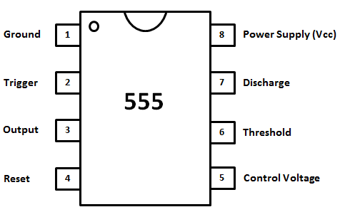

*In the 555 )time based oscillator( :*

*T = time period in seconds (s)*

*f = frequency in hertz (Hz)*

*R1 = resistance in ohms =470KΩ*

*R2 = resistance in ohms =470KΩ*

*C = capacitance in farads (F) =1µF*

*Thus:*

*F =*

*The 1Hz astable clock pulse provided by the 555 timer oscillator is fed into each BCD counter of the seconds’ stage.*

*The BCD counter provides a 4 bit(8421) synchronous logic output for every clock pulse received as shown in* ***Table1 2.2***

|  |  |  |  |  |  |
| --- | --- | --- | --- | --- | --- |
| *Palse* | *D(8)* | *C(4)* | *B(2)* | *A(1)* | *output* |
| *0* | *0* | *0* | *0* | *0* | *0* |
| *1* | *0* | *0* | *0* | *1* | *1* |
| *2* | *0* | *0* | *1* | *0* | *2* |
| *3* | *0* | *0* | *1* | *1* | *3* |
| *4* | *0* | *1* | *0* | *0* | *4* |
| *5* | *0* | *1* | *0* | *1* | *5* |
| *6* | *0* | *1* | *1* | *0* | *6* |
| *7* | *0* | *1* | *1* | *1* | *7* |
| *8* | *1* | *0* | *0* | *0* | *8* |
| *9* | *1* | *0* | *0* | *1* | *9* |

***Table1 2.2 : Logic output for numbers 0 – 9***

*The BCD output is then fed into the decoder as* ***picture1 2.3***

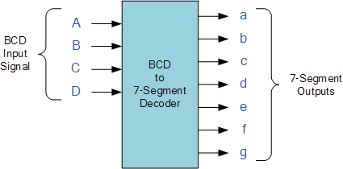

***Picture1 2.2***

*and display in 7-Segment as shown in* ***Table2 2.2, Picture2 2.2***

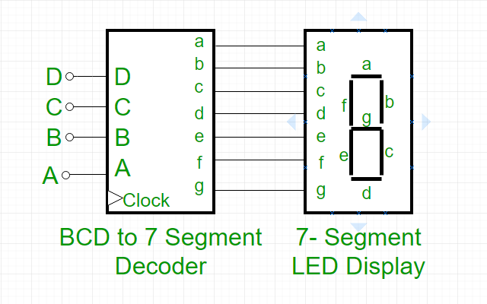

***Picture2 2.2***

|  |  |  |  |  |  |  |  |  |
| --- | --- | --- | --- | --- | --- | --- | --- | --- |
| *palse* | *BCD* | *A* | *B* | *C* | *D* | *E* | *F* | *G* |
| *0* | *0000* | *1* | *1* | *1* | *1* | *1* | *1* | *0* |
| *1* | *0001* | *0* | *1* | *1* | *0* | *0* | *0* | *0* |
| *2* | *0010* | *1* | *1* | *0* | *1* | *1* | *0* | *1* |
| *3* | *0011* | *1* | *1* | *1* | *1* | *0* | *0* | *1* |
| *4* | *0100* | *0* | *1* | *1* | *0* | *0* | *1* | *1* |
| *5* | *0101* | *1* | *0* | *1* | *1* | *0* | *1* | *1* |
| *6* | *0110* | *0* | *0* | *1* | *1* | *1* | *1* | *1* |
| *7* | *0111* | *1* | *1* | *1* | *0* | *0* | *0* | *0* |
| *8* | *1000* | *1* | *1* | *1* | *1* | *1* | *1* | *1* |
| *9* | *1001* | *1* | *1* | *1* | *0* | *0* | *1* | *1* |

***Table2 2.3 Output of the BCD to 7-Segment.***

1. ***Design***

***4.1 Simulation (Proteus)***

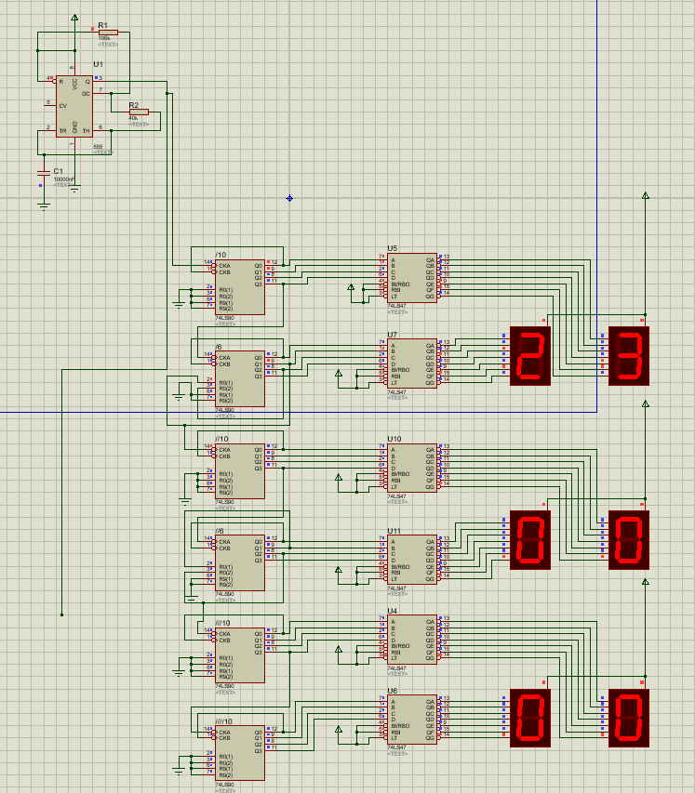

***4.2 Hardware***

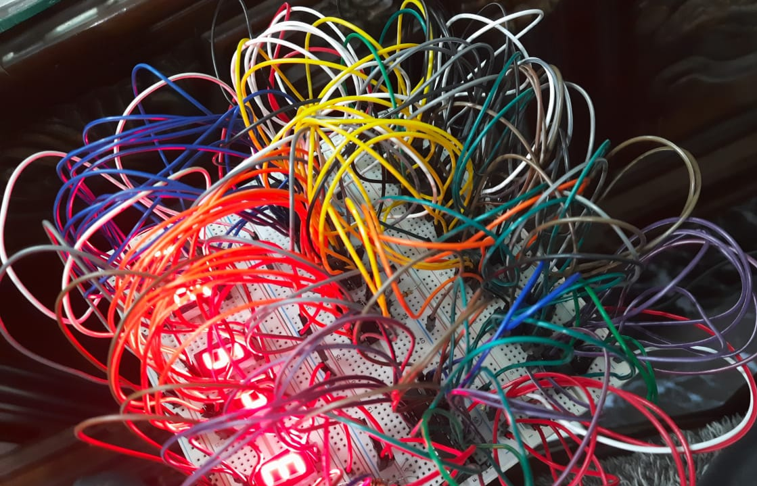

# *Conclusion*

*Digital electronic components were investigated and a 555 timer, a 74LS90 IC, a 74LS47Decoder and a seven segment display were combined to form a digital timer circuit. Different methods were analyzed to determine the best technique for creating an efficient timer until onewas chosen and the circuit was designed. The chosen circuit was verified through live wiresimulation. This design was then implemented and modified to suit the needs of the project.Problems were analyzed and repaired where necessary until it was concluded that the circuit hadmet the design criteria of the project. Once the correct operation of the circuit was verified, avero board implementation was designed in order to make the circuit more concise and more accurate.*